UDFs can be held at Appointment, Person (employee) or Recruitment level.

Contents

1. Completing the template 2
2. Basic UDF Set Up 4
3. Defining the field items 4
4. Defining where the UDF is to appear 5
5. Defining the List of Values (LoV) 6
6. Entering a format for numeric fields 7
7. Adding Security Options (optional) 7
8. Granting Access to secured UDFs 7
9. Editing or removing an existing UDF 8
9.1. Editing or removing a List item (List of Values) 8
9.2. Editing or removing a Field item (Label) 10
9.3. Removing a UDF from use 11
9.4. Deleting a UDF 11

Document Version Control
Change History/Review Details
Date | Version | Review by | Summary of Change
 | 1.0
Nov/Dec20 | 2.0 | HC | Updated following the implementation of V28

Knowledge Article: User Defined Fields (UDF) Knowledge Article.docx

Report(s)

UDFs are reported on in a variety of reports. Some have bespoke reports e.g. Academic Title, others are included in a larger report e.g. Qualifications are included in PERDEP01 Staff in Post report.
When creating a new UDF you will need to consider how the content will be reported on.

Other related Documents

MASTER UDF Template v2 in P:\PROJECTS\HRIS Programme\12. Support\Reference Data\UDFs\

A: Preparing to create a new UDF

When creating a new UDF it is advisable to complete the Excel template to record the requirements before you begin creating the UDF in CoreHR. The Excel version replicates a UDF and enables you to test the intended field labels and list items and ensure that you do not exceed the character limits. You can also preview the UDF to ensure that the system version will display as expected.

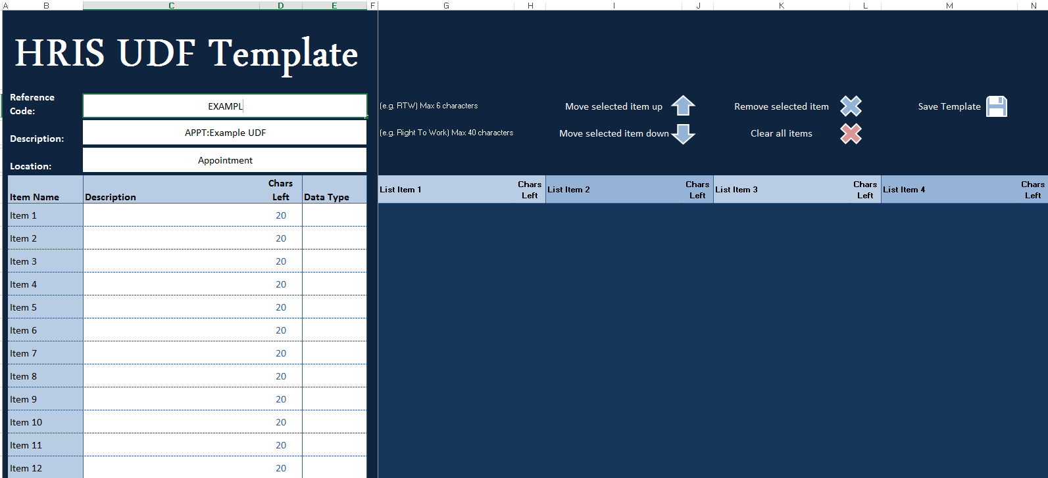

Completing the template

  - Create a new folder for your new UDF under P:\PROJECTS\HRIS Programme\12. Support\Reference Data\UDFs\[UDF name and date]

  - Save a copy of the master UDF template in your new folder and complete as follows:

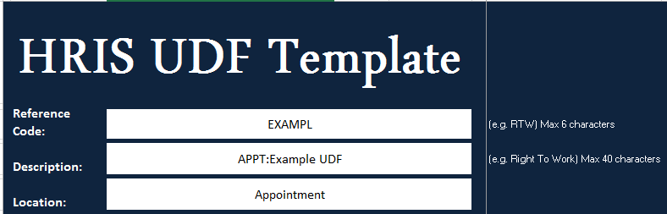

Field Name | Description
Reference Code | Enter a unique 6 character reference code (usually an abbreviation of the description)
  Description | Enter the description as it will appear on the final UDF (limit 40 characters).  NB: If you are creating a UDF to be held at appointment level the Description must begin “Appt:”
Location | Enter/Select Employee, Appointment, Recruitment
The next section enables you to enter the Field Items (labels) and choose the Data Type.

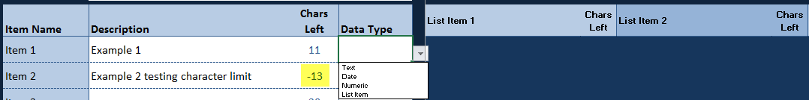

Field Name | Description
Description | Enter the Field Item (label) as you want it to appear on the UDF
Chars Left | Updates automatically to show how many characters are left/have been exceeded.
  Data Type | Select from the drop-down list.  NB: If you select ‘List Item’, you will also need to enter the items to appear in the drop-down list (max 12).

  - If applicable enter List items (max 12). Again the ‘Chars Left’ field will update automatically to show how many characters are left/have been exceeded.

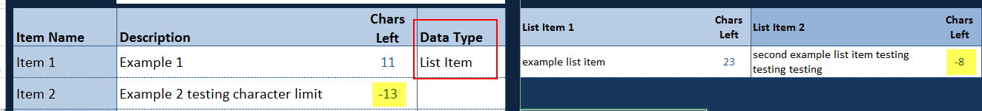

  - Once you have entered all of the details into template spreadsheet, click on the Preview tab. To make any changes – go back to the UDF Template tab.

 | NB the view will depend upon your individual display settings. You may need to adjust these to view the template accurately.

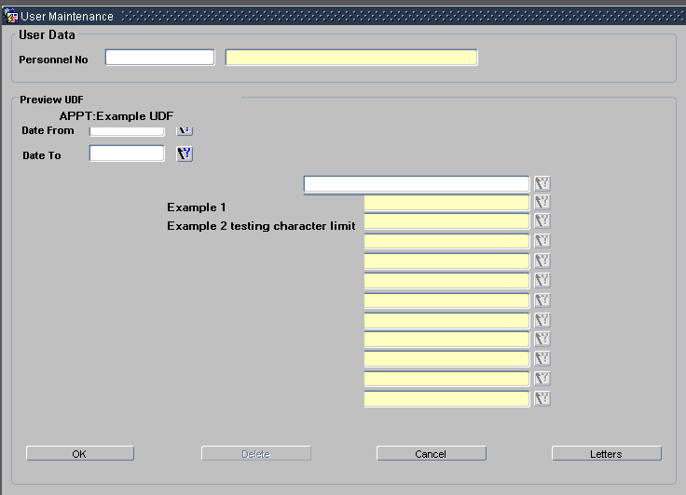

  - If you need to re-order or remove a field item, use the up and down arrows and delete options in the header.

 | NB: DO NOT delete any rows or attempt to Copy and Paste them as this will corrupt the template spreadsheet.

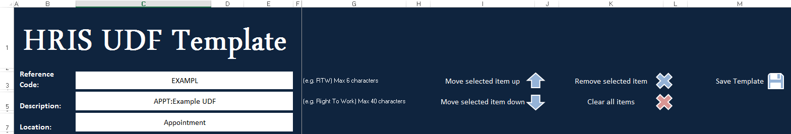

B: Creating the UDF

Basic UDF Set Up

Core Portal>Data Centre>HR Admin Setup Settings>User Defined Objects

  - Click on the 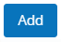 button to create a new UDF. This will insert a row for you to create the UDF.

  - Enter a unique Reference Code (max 6 characters)

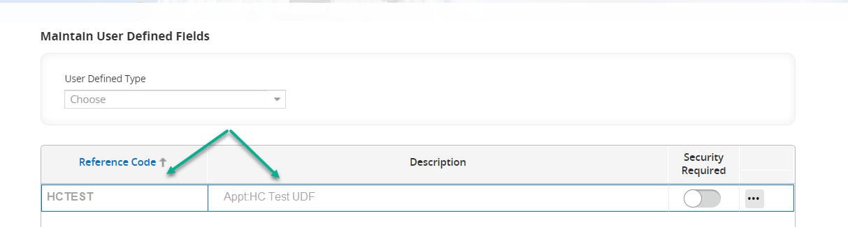

  - Enter a Description for your new UDF (max 40 characters).

  - SAVE

 | NB: If you are creating a UDF to be held at appointment level the Description must begin “Appt:” (there should be no space between the “Appt:” and the main description).

Defining the field items

There is a maximum of 12 fields items that can be included in a UDF.

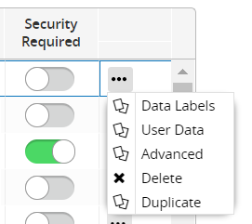
  - Click on Ellipses next to your new UDF description and choose Data Labels:

In the Data labels screen:

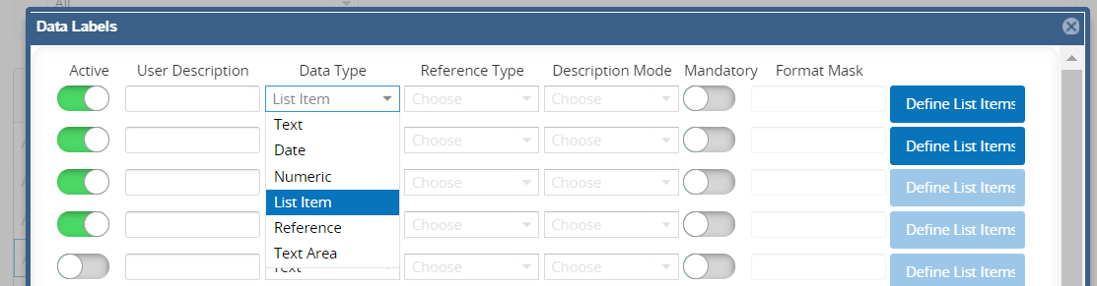

  - Update as follows:
Field Name | Description
Active* | Slide the toggle for each line entered to ensure the item appears on the UDF
User Description* | Enter the field name (label) as you want it to appear on the UDF
Data type* | Select from the drop-down list.
Reference type | Not used
Mandatory | Not used
Format mask | For numeric values only

  - Click OK to save

Defining where the UDF is to appear

  - Click on the Ellipses and choose Advanced.

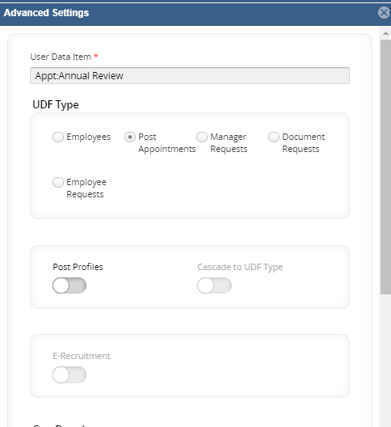

  - To create an appointment UDF tick Post Appointments, to create a Person UDF tick Employees, to create a Recruitment UDF click on E-Recruitment.

  - In the next section tick Post Profiles to create a UDF in Personnel or E-Recruitment to create a UDF in the e-Recruitment module.

  - Click OK to SAVE.

Defining the List of Values (LoV)

If you have created a ‘List item’ you will need to create the individual items to appear in the drop-down list.

  - From the Data Labels screen click on the Define List Items button at the end of the row for the relevant item.

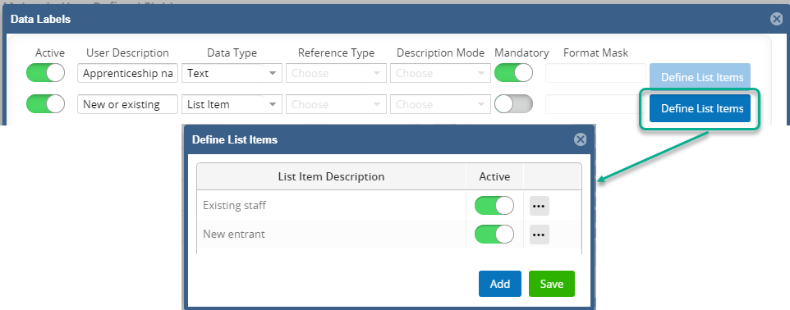

  - Click on Add, enter the Description and toggle the Active indicator. Repeat for each list item and SAVE.

Entering a format for numeric fields

  - Enter the required format into the Format Mask column.

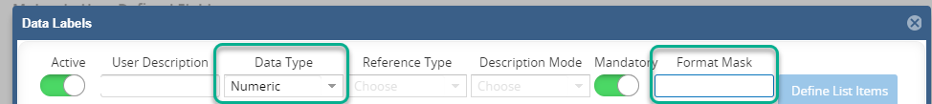

  - SAVE

  - To review how the UDF will appear click on User Data.

Adding Security Options (optional)

Most UDFs are automatically available to users who have the Personnel Administrator and/or Recruitment Administrator user roles. However, some UDFs require additional security.

You can apply security to the UDF by ticking Security Required:

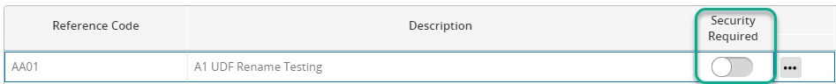

User access then needs to be granted via the security module.

Granting Access to secured UDFs

Core|Portal > Core Security > Set Up > System Users

  - Select the Accounts radial option to determine if setting up access for the Portal or Back Office.

  - Enter the Username of the user you are granting access for, this will either be the SSO for Back Office or Personnel No for Portal.

  - In the Security Type and Access Level fields select ‘User Defined Access’ and click on Show Access. A list of available UDF’s will be displayed.

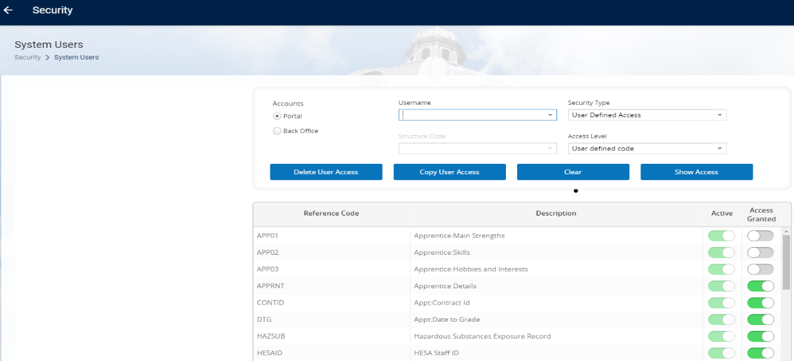

  - To assign or remove access use the toggle in the Access Granted column againt the relevant UDF .

  - Save and exit via the navigation breadcrumb.

Repeat the process for each user requiring access to the UDF.

Editing or removing an existing UDF

Great care must be taken if you are editing or removing an existing UDF. Any changes made will affect all existing records where the edited field(s) have previously been selected. It may prevent users from viewing or editing the UDF and/or an error message will be displayed when the UDF is opened on an affected record.

Refer to the Knowledge Article for full details on what changes can be made and other actions to consider.

  - Editing or removing a List item (List of Values)

Core Portal>Data Centre>HR Admin Setup Settings>User Defined Objects

This guidance assumes that any records affected by the change have been identified and steps taken to update them accordingly.

    - Click on the ellipses against the UDF you are editing and choose Data Labels

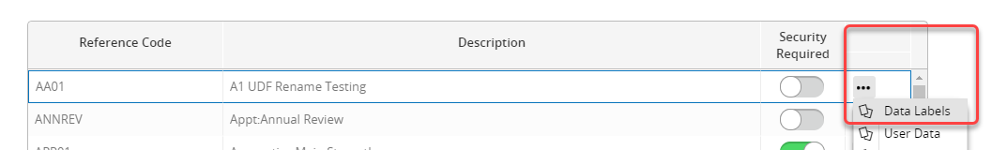

    - Click on Define List Items against the relevant menu item.

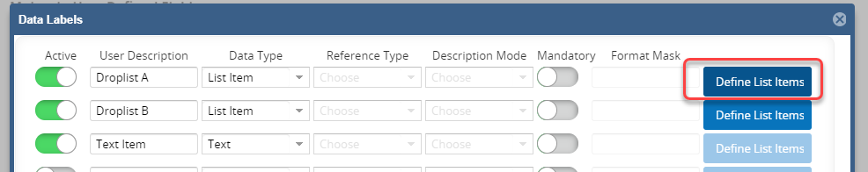

    - Edit/overtype the List Item Description(s) as required.

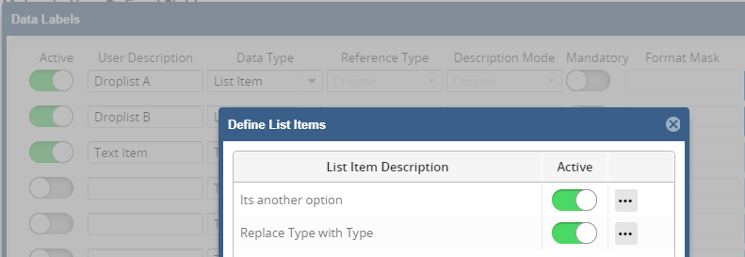

    - To remove a List Item click on the Ellipses and choose Delete

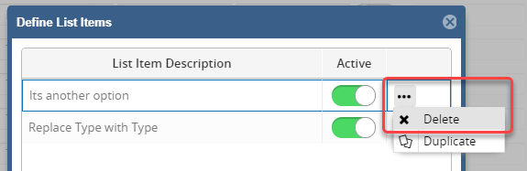

    - Save and OK.

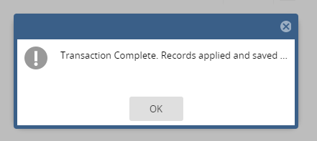

    - Cancel or click on the cross to exit

  - Editing or removing a Field item (Label)

Core Portal>Data Centre>HR Admin Setup Settings>User Defined Objects

This guidance assumes that any records affected by the change have been identified and steps taken to update them accordingly.

 | NB: If a Field Label is to be deleted you will need to delete the associated List Items. See steps in section 9.1

    - Click on the ellipses against the UDF you are editing and choose Data Labels



    - Edit/overtype the List Item Description(s) as required.

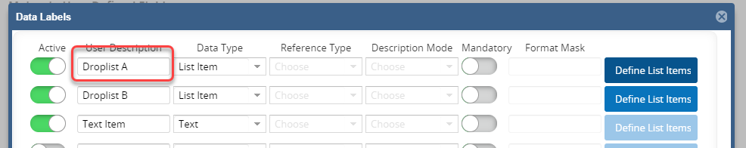

    - Save and OK.

 | NB: You will also need to update any reports that return data from the UDF to show the new Field Item (label).

  - Removing a UDF from use

This guidance assumes that all affected employee records have been updated to remove/replace the UDF.

Core Portal>Data Centre>HR Admin Setup Settings>User Defined Objects

    - Search for and the UDF being removed and edit the Description to include (Do Not Use)

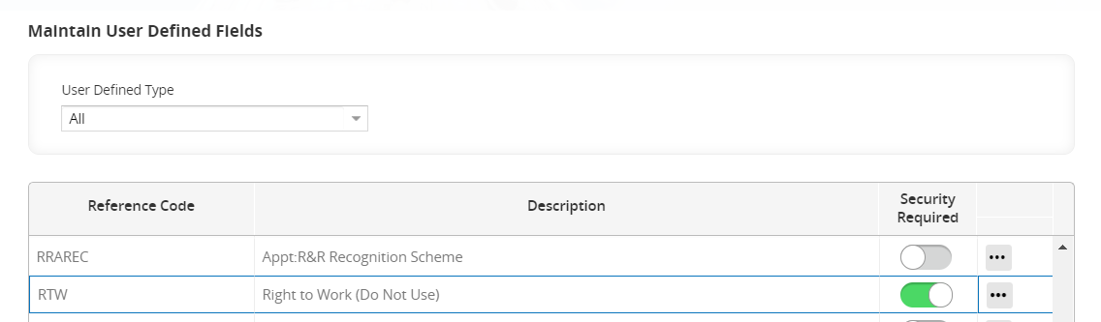

    - Toggle the Security Required button to ON. (If the UDF is already set to ‘Security Required’ ensure that all user access is removed)

  - Deleting a UDF

It is possible to delete a UDF, but it is more likely that you will want to mark a UDF as inactive/DO NOT USE, rather than deleting it completely. A UDF cannot be deleted if it has user data recorded against it.

Core Portal>Data Centre>HR Admin Setup Settings>User Defined Objects

    - Search for the UDF, click on the Ellipses and choose Delete.

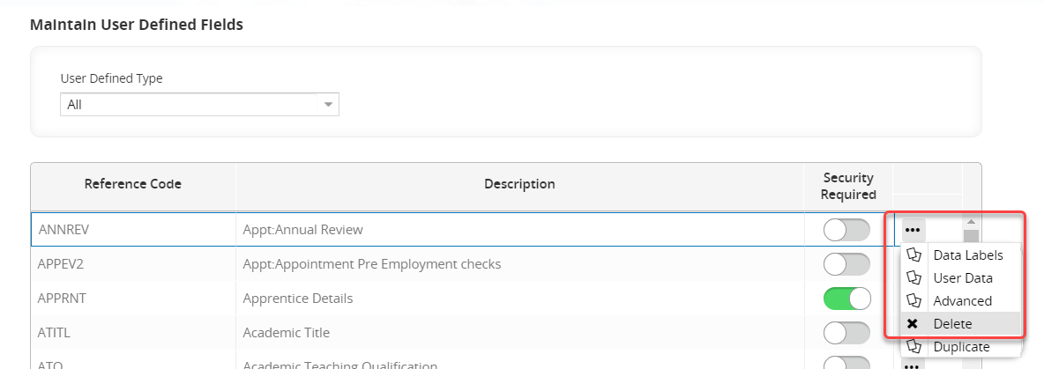

    - Click Yes to confirm.
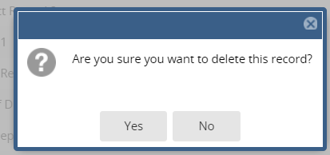

 | NB: If a UDF has had user data entered against it you will receive the following message and you will not be able to proceed

